## CANopen in the sensorlist

Since revision 3792 it is possible to select the CANopen protocol in NavVision. It is also possible to configure it in the sensorlist. CANopen is an application layer and communication profile that is used in several marine industries.

*: make sure that you read the “Software installation and commissioning manual”. The ICP needs some additional configuration to make the communication work.*

We will focus on the columns that are important. The other columns will all practically work the same as described earlier.

As example we will take a Naiad CANopen interface. As you can see in the following figure, the standard columns will be the same as you already learned.

First make sure that you select “CanOpen” as the protocol in the Devicelist. This will make NavVision aware to expect the CanOpen-protocol on that port.

### By hand

Make sure that you get the latest version of the manual from the manufacturer. It will give you the information you need to fill in to the sensorlist. In our example we use a manual from Naiad.

We are looking for the message details.

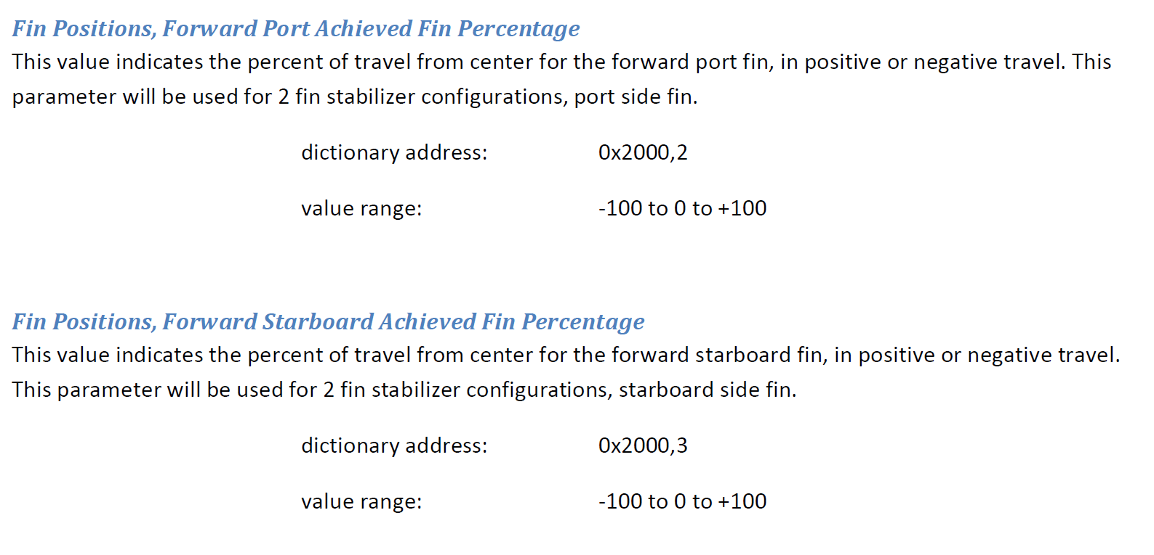

Figure 14‑9: Naiad manual

This information we are going to use to fill the column “Module” in the sensorlist. As you see it consists of structures with an ID. If, for example you want to read the “Fin position” you notice that the structure is 0x2000. For the forward Port one the ID is 2, for the Forward Starboard one the ID is 3. This will result in the value 0x200002 or 0x200003 that you will need to put into the “Module” column. This way you can find all the information on the I/O.

You still need to fill in the other columns as usual. This will result in a sensorlist as following:

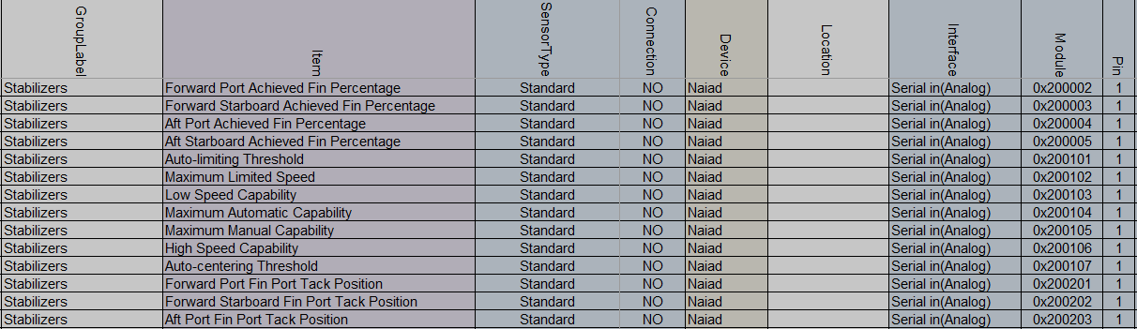

Figure 14‑10: Example CanOpen

Don’t forget to fill in the rest of the columns such as Field etc.

### By import

If the manufacturer can send you an EDS-file of the protocol (i.e. Naiad.eds), you can import the data into NavVision.

Rename the EDS-file to the network-connection it is attached to (i.e. canopen1_1.eds) and put it in the rootfolder of NavVision. Start and close-down NavVision and the structure will be available in the sensorlist_generated. Take care that it only goes for the column “Module” so you have to fill all the other mandatory columns by hand.

*: The structure of the eds file for import is canopen1_1, or canopen1_2, or canopen2_1. The first value is the interface-index (what number is the interface, i.e. 1 for the first ICP and so on). The second value is the source-ID. This is most likely 1, but depending on what they have set it could be any numver.*